FPGA Acceleration of Transformer Attention
Presentation Notes - Fused Step 5 Hardware-Verified State
Target: Xilinx Alveo U55C | Model source: TinyLlama one-head attention vectors | Updated: May 4, 2026

Executive Summary
Purpose: Give the audience the project in one minute.
- We built and verified an isolated FPGA attention pipeline for one TinyLlama attention head.
- The hardware path computes Q/K score, causal mask + scale, full-row softmax, and softmax @ V to produce attn_out.
- Track A Step 5 is now hardware-verified: score + mask/scale are fused into score_mask_scale_u55c_kernel.
- Synthetic sequence lengths S = 8, 64, 128, 256, 512 pass on the real U55C with the fused xclbin.
- Real TinyLlama vector runs pass for the legacy single-tile case, S = 16, and S = 64.
- All timing/utilization report artifacts and captured images are stored under docs/.
Speaker note: Emphasize that this is a correct isolated one-head attention accelerator, not full TinyLlama inference.

Project Scope
Purpose: Clarify what was implemented and what was intentionally excluded.
- Implemented offload boundary:
- Q_rot_int8, K_rot_int8 -> score_scaled_fp32 -> score_softmax_fp32 -> attn_out_fp32
- The fused branch computes raw INT32 scores internally but no longer writes raw scores back to HBM.
- Precision choices:
- Q and K are INT8 for bandwidth and compute density.
- Score accumulation is INT32 inside the score path.
- Mask/scale, softmax, V, and attn_out use FP32.
- Intentionally out of scope:
- Q/K/V projection GEMMs on FPGA
- Live RoPE generation on FPGA
- Full decoder-layer integration
- Full TinyLlama tokens/sec inference benchmark

Motivation
Purpose: Explain why attention was a useful FPGA target.
- Transformer attention has regular dense math and heavy memory movement.
- The score matrix grows as S x S, so sequence length quickly increases compute and storage demand.
- FPGAs let us specialize data layout, arithmetic precision, tiling, HBM placement, and kernel orchestration.
- This project tests the design on a real U55C, including hardware emulation, real-card execution, and post-route reports.

Current Architecture
Purpose: Show how data moves through the fused verified pipeline.
- Host/XRT prepares synthetic or exported real TinyLlama Q/K/V vectors.
- Tile shape: Q tile = 8 x 64 INT8, K tile = 64 x 64 INT8, score tile = 8 x 64.
- Full sequence coverage uses ceil(S/8) x ceil(S/64) score tiles per head.
- Fused pre-softmax path: score_mask_scale_u55c_kernel writes scaled FP32 logits directly.
- Full-row softmax is required for S > 64 because each query row must normalize across all keys.
- The fused xclbin uses HBM banks [0], [1], and [3]-[7]; HBM[2] is no longer needed for raw-score staging.

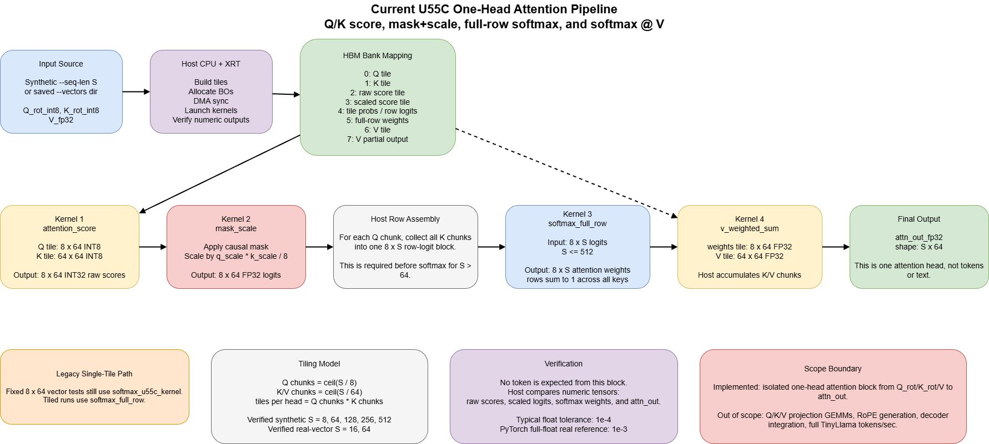
Figure: one-head attention pipeline diagram.
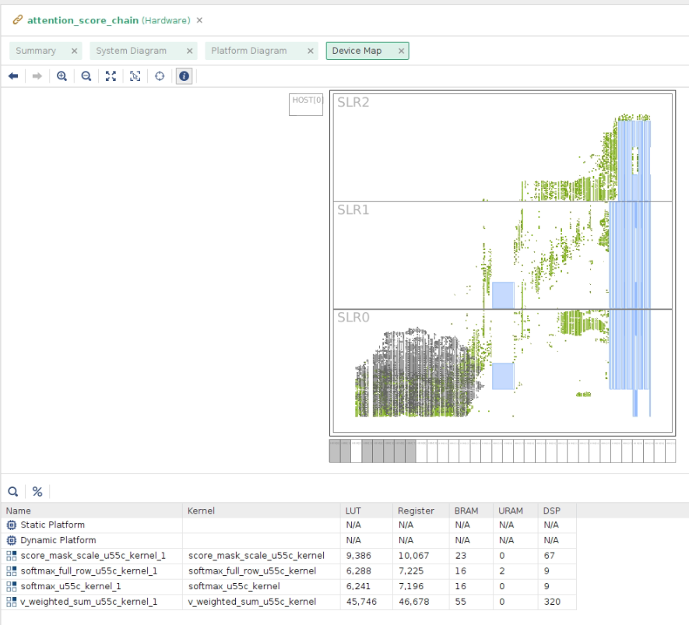
Figure: refreshed Vitis device/HBM map capture for the fused build.

Track Status
Use this slide to show the current completed scope and the remaining future work.
Track | Status | Notes
Track A: speedup + tiling | Steps 1-5 hardware-verified | Includes packed I/O, merged mask+scale, tiling, full-row softmax, pass-1 double buffering, and fused score+mask/scale.
Track B: softmax @ V | Complete | V weighted-sum kernel integrated; synthetic S=8..512 and vector modes verify final attn_out.
Track C: real TinyLlama inputs | Complete for current scope | TinyLlama Q/K/V extraction, INT8 Q/K quantization, real-vector export, and U55C runs for single-tile, S=16, S=64.
Track D: baselines/results | Staged design complete; fused retiming partially captured | Fused hardware timings are available from AGENTS/U55C run logs; Track D tables should be refreshed for fused-vs-staged comparison.
Future integration | Not implemented | Full TinyLlama subgraph, KV-cache-aware decode, and decoder-layer integration remain future work.

Implementation Highlights
Purpose: Summarize the important engineering decisions.
- 64-bit packed Q/K/score I/O was the first major score-kernel latency improvement.
- Full-row softmax made S > 64 correct by normalizing across the entire row.
- The V weighted-sum kernel completes one-head attention output instead of stopping at probabilities.
- Track A Step 5 fused score + mask/scale, eliminating the raw-score HBM write/read round trip.
- The fused kernel passed HLS csim/csynth, hw_emu, and real U55C runs.
- The fused hardware xclbin UUID is 56cd611d-8c32-c19b-f5ef-358bed40d459.

Verification Strategy
Purpose: Demonstrate that correctness was checked at multiple layers.
- Python reference verifies full-sequence tiling at S = 8, 64, 128, 256, 512.
- Local C++ benches verify individual HLS kernels against exported vectors.
- Fused score_mask_scale_u55c_kernel: HLS csim PASS and csynth PASS.
- Fused hw_emu passed vector mode and S=8 sequence mode.
- Fused real U55C synthetic sweep passed S = 8, 64, 128, 256, 512.
- Fused real U55C TinyLlama vector runs passed for real_tinyllama_tile, real_tinyllama_s16, and real_tinyllama_s64.
- Tolerance policy:
- Scaled logits and softmax: 1e-4
- Synthetic/quantized attn_out: 1e-4
- Real TinyLlama PyTorch float reference attn_out: 1e-3

Correctness Results
Purpose: Give the pass/fail headline without drowning the slide in logs.
- Fused real U55C --vectors sim/attention_score_tile passed with final attn_out verification.
- Fused real U55C synthetic S=8, 64, 128, 256, 512 all printed Tiled sequence verification PASSED and Attention output verification PASSED.
- Fused real U55C TinyLlama vector runs passed for sim/real_tinyllama_tile, sim/real_tinyllama_s16, and sim/real_tinyllama_s64.
- Post-route timing met all user timing constraints.

Fused Hardware Timing Results
These are real U55C fused-branch timings for the isolated one-head attention block, not full-model tokens/sec.
Case | Fused FPGA total ms | Previous staged total ms | Notes
Synthetic S=8 | 0.296 | 0.803 | Fused path removes one pre-softmax kernel launch and raw-score HBM staging.
Synthetic S=64 | 2.364 | 2.864 | Same final attn_out verification.
Synthetic S=128 | 5.484 | 6.992 | First multi-K-chunk comparison point.
Synthetic S=256 | 17.307 | 20.570 | Fused path improves total time but softmax/V stages remain staged.
Synthetic S=512 | 60.328 | 72.941 | Largest tested synthetic length.
real_tinyllama_tile | 0.635 | 0.258 | Small single-tile runs are sensitive to fixed overhead/cold effects.
real_tinyllama_s16 | 0.569 | 1.488 | Real TinyLlama full-sequence vector run.
real_tinyllama_s64 | 2.004 | 3.094 | Real TinyLlama full-sequence vector run.

- Interpretation: Step 5 improves the larger synthetic and full-sequence real-vector cases by reducing staged pre-softmax overhead.
- The design is still staged after pre-softmax: full-row softmax and softmax @ V continue to use separate kernels and HBM buffers.

CPU/GPU/FPGA Baseline Context
The CPU/GPU baseline table is from the staged Track D results and is still useful context. The fused FPGA column should be used for current hardware timing.
S | CPU full attn ms | GPU full attn ms | Staged FPGA total ms | Fused FPGA total ms
8 | 0.0322 | 0.3349 | 0.803 | 0.296
64 | 0.2920 | 0.2507 | 2.864 | 2.364
128 | 2.5009 | 0.2998 | 6.992 | 5.484
256 | 3.9523 | 0.2726 | 20.570 | 17.307
512 | 12.3290 | 0.2461 | 72.941 | 60.328

- The GPU baseline was collected on a separate Windows RTX 3050 Laptop GPU and should not be presented as same-host U55C data.
- Even after fusion, this isolated one-head workload is still slower than CPU/GPU baselines; the value of Step 5 is architectural progress toward fewer launches and less HBM staging.

Fused Post-Route Utilization
Use the refreshed post-route reports under docs/ for final fused FPGA utilization numbers.
Scope | LUT | REG | BRAM | URAM | DSP
User kernels | 60,983 | 70,401 | 110 | 2 | 405
Full routed design | 191,648 CLB LUTs | 253,388 CLB registers | 309.5 Block RAM tiles | 2 | 409

- Full routed design usage: 14.70% CLB LUTs, 9.72% registers, 15.35% BRAM, 0.21% URAM, 4.53% DSP.
- The V weighted-sum kernel still dominates DSP usage: 320 DSP. The fused score_mask_scale kernel uses 67 DSP and 23 BRAM.
- Post-route timing closed: WNS 0.003 ns, TNS 0, WHS 0.009 ns, no failing setup/hold endpoints.
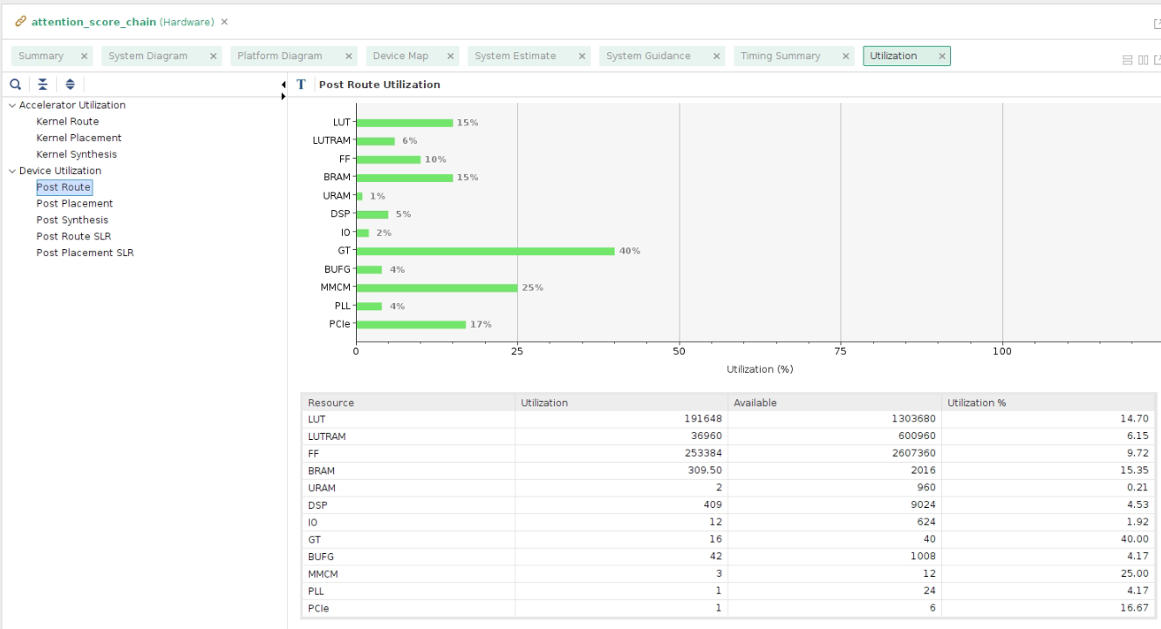
Figure: refreshed fused post-route utilization capture.
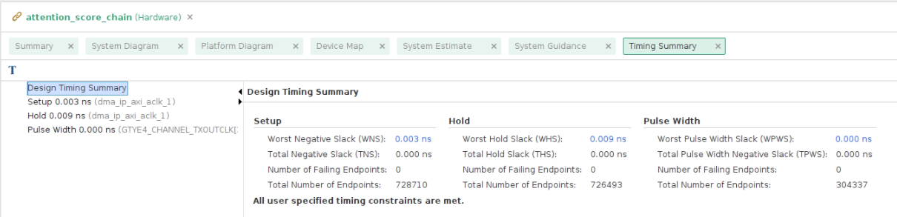
Figure: refreshed fused post-route timing summary capture.

Report Artifacts Under docs/
All timing, utilization, xclbin, system-estimate, and captured-image artifacts used for the presentation are stored under docs/.
File | Use in presentation
docs/track_d_results.md | Staged CPU/GPU/FPGA timing tables and interpretation; refresh this later with fused comparison tables.
docs/PostRouteKernelUtilization.rpt | Per-kernel fused routed utilization. Use this to explain DSP/BRAM by kernel.
docs/PostRouteFullUtilization.rpt | Full fused routed U55C utilization including platform resources. Use this for headline percentages.
docs/PostRouteSLRUtilization.rpt | SLR resource distribution and SLL usage. Useful for placement/spread discussion.
docs/PostRouteTimingSummary.rpt | Fused post-route timing closure. Source for WNS/TNS/WHS and no failing endpoints.
docs/PostRouteTimingSummary.rpv / .rpx | Vivado report viewer/project artifacts for deeper timing inspection.
docs/PostRouteUtilization.xlsx | Spreadsheet copy of utilization for charts or quick slide edits.
docs/system_estimate_attention_score_chain.xtxt | Full fused xclbin system-estimate output.
docs/system_estimate_score_mask_scale_u55c_kernel.xtxt | Fused pre-softmax kernel system estimate.
docs/system_estimate_softmax_u55c_kernel.xtxt | Legacy tile softmax system estimate.
docs/system_estimate_softmax_full_row_u55c_kernel.xtxt | Full-row softmax system estimate.
docs/system_estimate_v_weighted_sum_u55c_kernel.xtxt | V weighted-sum system estimate.
docs/attention_score_chain_xclbin_info.txt | xclbin content, UUID, kernels, clocks, and memory topology.
docs/attention_score_chain_xclbin_link_summary.txt | Vitis link summary and command/config mirrors.
docs/system_diagram_fused.json | Fused system-diagram JSON preserved from Vitis save-temps.
docs/vpp_*_guidance.html | Vitis compile/link guidance pages for each kernel and link step.
docs/PlatformDiagram.pdf and docs/SystemDiagram.pdf | Generated Vitis platform/system diagrams.
docs/attention_architecture.png | Presentation architecture figure.
docs/DeviceMap.png | Device/HBM map capture.
docs/post_route_utilization.png | Utilization screenshot for slides.
docs/timing_summary.png | Timing closure screenshot for slides.

Challenges
Purpose: Explain what made the project nontrivial.
- Softmax is row-global: S > 64 cannot be normalized correctly one 8 x 64 tile at a time.
- The host must assemble full S-wide rows before launching full-row softmax.
- Staged kernels are easy to debug but create extra HBM traffic and launch overhead.
- Fusing score + mask/scale required preserving correctness while changing the host and xclbin kernel graph.
- Real TinyLlama data required careful Q/K/V extraction, RoPE alignment, grouped-query head mapping, and quantization validation.

Current Limitations
Purpose: Keep the claims honest.
- This is one selected attention head, not all TinyLlama heads and layers.
- Q/K/V projection and RoPE are still produced by software/export scripts, not FPGA kernels.
- The fused design improves over the staged FPGA path but is still slower than CPU/GPU for this isolated one-head workload.
- Real TinyLlama full-sequence FPGA tests are currently S = 16 and S = 64. Synthetic --seq-len tests have already covered S = 128, 256, and 512; only larger real TinyLlama vector directories remain optional follow-up.
- Full TinyLlama integration and model-level tokens/sec are future work.

Next Steps
Purpose: Show the immediate engineering path after the current state.
- Use docs/track_d_results.md as the current fused-vs-staged timing and utilization source.
- Optional: generate and run larger real TinyLlama vector directories such as real_tinyllama_s128, real_tinyllama_s256, and real_tinyllama_s512 if the final demo needs broader real-input coverage.
- Investigate additional fusion after softmax/V only if the algorithmic data dependencies can be handled cleanly.
- Connect this block into a fuller TinyLlama attention subgraph.
- Longer-term: add KV-cache-aware decode and eventually integrate into a decoder-layer flow.

Suggested Slide Order
- Title and project goal
- Why attention is a bottleneck
- Offload boundary and what is out of scope
- Architecture diagram and device map
- Track A-D implementation status
- Verification flow
- Correctness results
- Fused hardware timing results
- CPU/GPU/FPGA baseline context
- Fused post-route utilization and timing closure
- Report artifacts/source files under docs/
- Limitations and honest interpretation
- Next steps

Appendix: Key Files To Reference
- AGENTS.md - latest project-state handoff and fused Step 5 verification summary
- docs/implementation_checklist.md - track status and implementation plan
- docs/track_d_results.md - fused-vs-staged CPU/GPU/FPGA timing and interpretation
- docs/PostRouteKernelUtilization.rpt - fused per-kernel routed utilization
- docs/PostRouteFullUtilization.rpt - fused full routed design utilization
- docs/PostRouteTimingSummary.rpt - fused timing closure details
- docs/attention_score_chain_xclbin_info.txt - fused xclbin UUID, kernels, clocks, and topology
- docs/attention_architecture.drawio / .png - architecture diagram
- host/attention_score_chain_xrt.cpp - XRT host orchestration
- hls/score_and_mask_scale/ - Track A Step 5 fused kernel

